**Unit 4 – Blockchain and Decentralized Applications**

**Lab 2 Manual**

**Introduction to Solidity Programming with VS Code and Truffle**

**Objective:**

In this lab, students will set up a local blockchain environment using Truffle and Ganache, deploy a simple smart contract, and interact with it through the Truffle console.

By the end of this lab, students will:

* Understand the basics of Solidity using VS Code.
* Write a simple smart contract and interact with it.
* Deploy and interact with the contract using VS Code and Ganache blockchain.

**Step 1:** Setting Up VS Code Environment

* Click on View menu, select Terminal from the drop down menu.
* Type *mkdir Lab2* by creating a folder
* Type *cd Lab2* to get into the directory
* Then, type *npm -v* to find out if you have npm installed if yes then type *npx create-react-app Lab2* to create a react application

* If the name of the project is in capital letters, I will throw an error, so always use the name in lowercase letter.

* It asks for confirmation, press ‘y’.

* After the installation is complete, close the terminal.
* Go to File menu and click on Open Folder. You can go to the directory. You will see the complete files created by the command in explorer area.
* A screenshot of a computer program

  Description automatically generated

**Step 2:** Install Ganache from [Ganache](https://archive.trufflesuite.com/ganache/)

After installing, click on quick start and you will see the interface somewhat like this:

please do not close this application. We want it running at the backend.

**Step 3:** Come back to your VS Code terminal

Type *npm install truffle*

After the installation is complete, please close the terminal and open a new terminal.

**Step 4:**

Type *npm install -g truffle* to install truffle in your environment. Sometimes it gives issues so, please permit your running scripts enabled on your system.

Set the execution policy:

set-ExecutionPolicy -Scope CurrentUser -ExecutionPolicy RemoteSigned

Revert the execution policy:

*set-ExecutionPolicy -Scope CurrentUser -ExecutionPolicy Restricted*

The truffle will be installed successfully

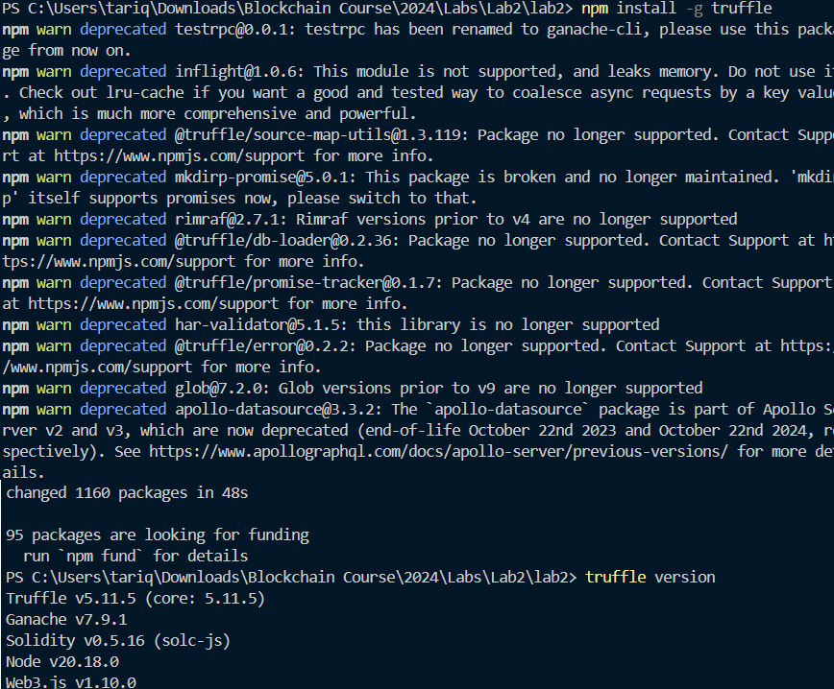

Now,

Initialize truffle by typing *truffle init*

***Note***:

If the truffle was initialized earlier on same contract, your command will look like this:

After initializing, you will see the truffle-config.js file in the explorer tab.

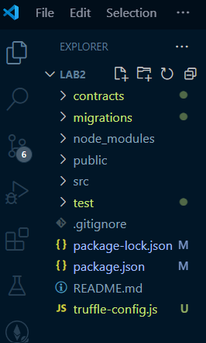

**Step 5:** Open Ganache, go to settings and add your project to it by adding the truffle-config.js file.

Also confirm the port number and network ID i.e.,

Then, click on save and restart.

Go back to VS Code terminal and type *truffle console*

You will see that the truffle console is open with ganache

Add a file to your contract and save it:

Or if want, you can add the contract which we have compiled and executed in our first lab.

Also,

Add the file 1_migtestcontract.js and save it:

In the truffle console now you can type *compile*

Now, if you see the Ganache, it holds your compiled contract

Since our contract is compiled successfully, now type *.exit* to exit from the truffle console environment.

Soon as you exit, then type *truffle migrate -reset*

Soon as you run the command truffle migrate -reset, your contract will be deployed.

Brava! Your contract is deployed successfully. This is how it will look like in terminal:

And, you can also see it on Ganache interface i.e.,

**Step 6 (Optional):**

To verify get again into the *truffle console* by typing it in the terminal

In the console, type *const acc=await TestContract.deployed()* OR

*const instance = await TestContract.deployed();*

Now your contract is deployed successfully and verified.

**Task:**

"🚀 Challenge Lab: Decentralized Dev in Action! 🚀

This week, you’re invited to dive into Truffle and Ganache on VS Code—getting hands-on with core blockchain tools! Here’s the URL you’ll need to get started: <https://ferdyhape.medium.com/remix-ide-and-ganache-a-beginners-guide-to-smart-contract-deployment-b0df68c48ae6>

While this isn't a graded task, those who complete it will be rewarded with chocolate 🍫 as a small bonus. Plus, who knows? If the professor is impressed, it *might* just turn into a credited assignment!

So, take this opportunity to explore freely, experiment with settings, and start building like a true blockchain developer. We’ll meet up later to chat about your findings and any new insights. I can't wait to see where you take it—have fun, and happy coding!"